Hamburg Area Youth Baseball League

2023 Spring Registration Form

Welcome to the 2023 Baseball Sign Ups. Sign-ups are welcome to all kids 5-12 years of age (as of May 1, 2023) Children will be able to sign up for the following levels in our recreational league: T-Ball, B-Ball, A-Minor, or A-Major

Practices will begin in Feb/March with open gyms at the field house starting in January. Follow our new Facebook page “Hamburg Area Youth Baseball League” for updates.

There is also an opportunity to sign up for travel team, which would be an additional cost made up of all the organization. Depending on interest, try outs may be held.

2 ways to SIGN UP!

1. Please go to the following link to sign up via google doc: <https://tinyurl.com/yupd7efv>

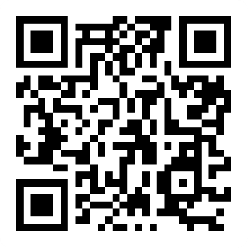

1. **ONE** in person sign up: SATURDAY December 17th, 2022 9a-11a @ Tilden Elementary School.

\*\***Registration fee is $50** / Write checks out to “Hamburg Area Youth Baseball League” and send to PO Box 184, Hamburg, Pa 19526 **OR** bring it to the in person sign up.

Any questions please reach out to the HAYBL president Josh Krick at [kricky17@aol.com](mailto:kricky17@aol.com) or 610.914.9501

**FORM AND PAYMENTS ARE DUE NO LATER THAN JANUARY 13th, 2023.**

